Your Name x

Section 1: Business Insights: Global (formerly Business and Company Resource Center)

- What is the company name and contact information (company URL and e-mail address)?
x
Name: Exxon Mobil Corporation;
URL: https://www.exxonmobil.com;
e-mail address: customer.care@exxonmobil.com;

- In what type of business is this company involved?
x
Petroleum Refining

- Identify one of the company’s industry NAICS codes and its name.
x
NAICS code: 324110
Petroleum Refineries

- What is its ticker symbol?
x
XOM in New York Stock Exchange.

- In what year was this company founded?
x
Founded in 1999, by a merger of two 1870-founded Standard Oil Companies.

- How many employees does it have?
x
74900 by 2019.

- What is its annual operating revenue?
x
US $264.9 billion.

- From the left-hand side, select either the “Journals” link or the “Recent News” link. Find one article of interest. Using the correct APA format, write a full bibliographic citation. The format you see online is not necessarily the correct APA format so put the correct information in the correct order and format. See assignment instructions for details.
x
Exxon Mobil. (2019, July 15). Innovating energy solutions: Research and development highlights.

- Click on the link to “Company Profiles.” What is the company’s ticker symbol? What is the name of the stock exchange on which the stock is traded?
x
Ticker symbol: XOM.
Stock Exchange name: Exxon Mobil Corporation.

- In the Company Profile, select the Rankings link. Choose a document title. What is the document title? What is the ranking method? What number is your company on this list?
x
Document name: World’s Most Admired Companies - 2020;
Ranking Method: Corporations measured by revenue.
Ranking Position: 11

- In the Company Profile, identify the company’s primary industry and its NAICS code. Click on the primary industry and provide one interesting piece of information.
x
Petroleum Refining industry;
NAICS code: 324110;
The petroleum industry continues to thrive despite the rampant campaign of green energy; with the United States 2019 oil production being more than double the production in 2009.

Section 2: Business Source Complete

- Find an article about your company in this database. To begin, add your company’s name in the first search field (see screen shot below). In the “Select a Field” box, pull down the menu and search by “Company Entity.”

Add a second keyword search term of your own choosing in the search field on line two to narrow your search. Answer the questions below the screen shot.
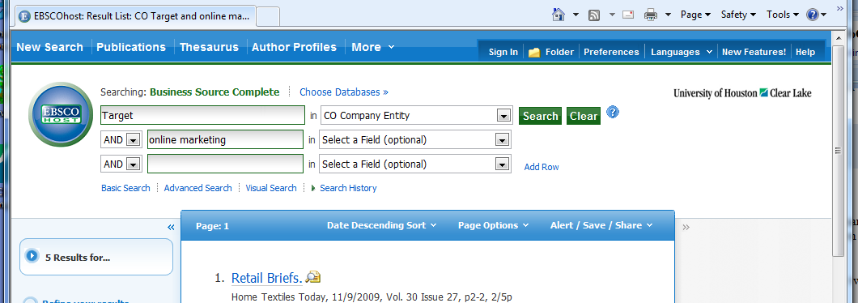

  - What was the keyword you used in the search field on line 2?
x
Petroleum

  - How many entries did this search return?
x
Four

  - Do you think your choice of keyword in line 2 was a good one? Why or why not?
x
I think it was a good choice of keyword because if I used “energy”, it would have returned a wider list and if I used “petroleum refining companies”, the results woud have been too narrow.

  - Provide the bibliographic citation in correct APA or MLA format for one of the sources you retrieved in this search.
x
Kimball, R. (2010). The TULSA petroleum abstracts database: A comparison of two platforms. Science & Technology Libraries, 29(1-2), 92-110.

- Which database—Business Insights Global or Business Source Complete—do you think you will use most often for finding articles about your company? Why?
x
Business Source Complete
Because it has multiple well categorized databases that are easy to access and more user-interactive.

- Using Company Profiles (top of screen, under “More”), open the Datamonitor Report for your company. What is the date of your company’s report?

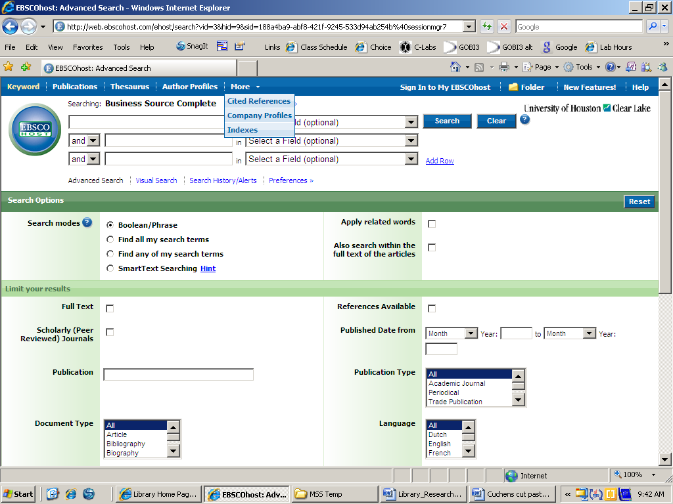

x
9th April, 2020.

- List three items in its Table of Contents.
x
2019 Financial and Operating Highlights;
2019 Business Highlights;
Business Source Complete.

- Find the SWOT analysis and identify the following. If your company does not have a SWOT analysis, do an advanced search using your company name and one of the SWOT terms as a keyword. Find an abstract and provide one significant fact. See screen shots below for an example.

  - A strength
x
Trusted and well known brand for more than a century.

  - A weakness
x
The attack on the company by environmentalist groups.

  - An opportunity
x
Increasing oil demands in developing countries.

  - A threat
x
Alternative energy sources with the improvement of technology.

If your company does not have a SWOT Analysis, use the search terms to locate information.
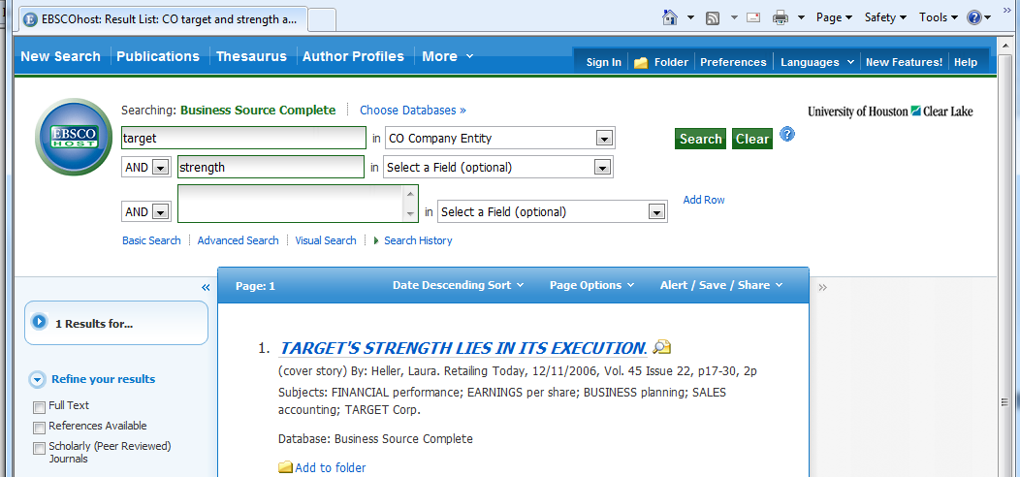

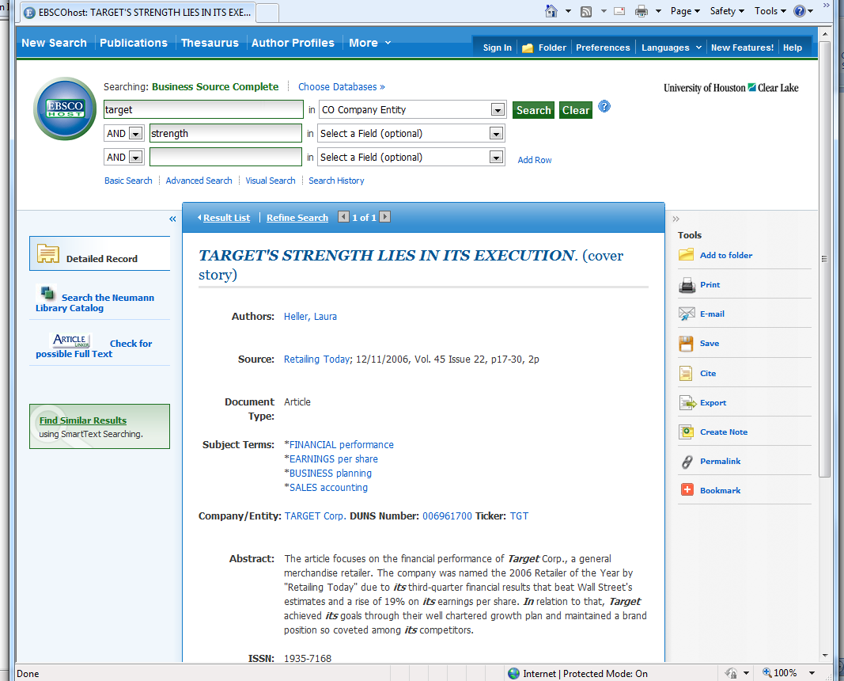

Section 3: Nexis Uni’s Company Dossier

- Go to the “Get Company Info” box and enter your company’s name or ticker. In Company Dossier, “click on your company. In the Snapshot, compare the number of employees to the figure found on Business and Company Resource Center. Is the number the same as #6 above? What does this tell you?
x
The number of employee is the same.

It means that the database is up to date.

- Review the company Snapshot. Who is the chief executive and what is his/her title?
x
Darren W. Woods
Chairman of the Board and Chief Executive Officer.

- Identify one of the company’s competitors.
x
Chevron Corp.
ConocoPhillips

Kimball, R. (2010). The TULSA petroleum abstracts database: A comparison of two platforms. Science & Technology Libraries, 29(1-2), 92-110.
Exxon Mobil. (2019, July 15). Innovating energy solutions: Research and development highlights.

